

Design Specification Document
Document Ref No: ITTP-BFE-xxx
Document Owner: xxxxxxx (IBM/ITTP Program)
Document Version: Version n.n

This document contains proprietary information. All information contained herein shall be kept in confidence. None of this information shall be divulged to persons other than MayBank and IBM employees authorized by the nature of their duties to receive such information, or individuals or organizations authorized by Maybank or IBM in accordance with existing policy regarding release of company information.

Maybank -IBM Confidential
Table of Contents

1. Document Control 3
1.1 Document Statistics 3
1.2 Summary of Changes 3
2. ESB Connectivity Parameters 4
2.1 Development 4
2.2 SIT 4
2.3 UAT-1 4
2.4 UAT-2 4
2.5 Queue Names 5
2.5.1 Input and Output Queue Names 5
2.6 JMS Naming 9
2.6.1 JMS naming 10
3. MQ Handler Properties 12
3.1 Development 12
3.2 SIT 13
3.3 UAT-1 14
3.4 UAT-2 15
4. ESB Facade Properties 17
5. JMS Setup 19
5.1 WAS 6 19
5.2 WAS 7 27

Document Control
Document Owner : xxxxxxxxxxxxx
Document Reference Number : ITTP-BFE-xxxx
Document Abstract : This document outlines the xxxxxxxxx.

Document Statistics
Type of Information | Document Data
Title
Document Type
Document version #
Last date document was updated
Document Filename
Document Owner
Document Owner Delegate
Document Author
Document Change Reviewers
Document Approvers

Summary of Changes
Version | Version Date | Description | Date Approved
0.1 | 27 July 2012 | Initial Version

ESB Connectivity Parameters

Development
Host | 10.4.71.79,  172.17.1.144 (NAT IP, used to access SG ESB DEV server from MY S1 DEV server)
Port | 2414
Channel | BFE.ALL.01
Queue Manager | SGGWD1
Output Queue | Refer to Section 2.5
Input Queue | Refer to Section 2.5

SIT
Host | 10.4.71.79
Port | 2416
Channel | BFE.ALL.01
Queue Manager | SGGWT1
Output Queue | Refer to Section 2.5
Input Queue | Refer to Section 2.5

UAT-1
Host | 10.4.71.79
Port | 2418
Channel | BFE.ALL.01
Queue Manager | SGGWU1
Output Queue | Refer to Section 2.5
Input Queue | Refer to Section 2.5

UAT-2
Host | 10.4.71.79
Port | 2419
Channel | BFE.ALL.01
Queue Manager | SGGWU2
Output Queue | Refer to Section 2.5
Input Queue | Refer to Section 2.5

Queue Names

Input and Output Queue Names
Output Queue | BFE.CIC.REQUEST.IN.01 (MQ Java API)  BFE.CIC.REQUEST.IN.02 (JMS API)
Input Queue | Refer to the next table  BFE.RESPONSE.DELAYED (Delayed queue)

Drop 1

Drop 2

Business Service Area | No | Business Service ID | Description | Transaction Type | Reply Queue
Deposit2 |  | BSD2101 | Cash Deposit | Transaction | BFE.ESB.DP2.RPL.UPD.01
Deposit2 |  | BSD2102 | Cheque Deposit | Transaction | BFE.ESB.DP2.RPL.UPD.01
Deposit2 |  | BSD2103 | Withdrawal | Transaction | BFE.ESB.DP2.RPL.UPD.01
Deposit2 |  | BSD2104 | Payment | Inquiry | BFE.ESB.DP2.RPL.INQ.01
Deposit2 |  | BSD2106 | Fund Transfer | Transaction | BFE.ESB.DP2.RPL.UPD.01
Deposit2 |  | BSD2108 | Misc Debit | Transaction | BFE.ESB.DP2.RPL.UPD.01
Deposit2 |  | BSD2109 | Misc Credit | Transaction | BFE.ESB.DP2.RPL.UPD.01
Deposit2 |  | BSD2111 | Account Closure | Transaction | BFE.ESB.DP2.RPL.UPD.01
Deposit2 |  | BSD2113 | TDA Placement | Transaction | BFE.ESB.DP2.RPL.UPD.01
Finance |  | BSFI111 | Finance Account Inquiry | Inquiry | BFE.ESB.FIN.RPL.INQ.01
Finance |  | BSFI112 | Collateral Inquiry | Inquiry | BFE.ESB.FIN.RPL.INQ.01
Finance |  | BSFI113 | Settlement Inquiry | Inquiry | BFE.ESB.FIN.RPL.INQ.01
Finance |  | BSFI115 | Disbursement Inquiry | Inquiry | BFE.ESB.FIN.RPL.INQ.01
Finance |  | BSFI116 | Outstanding Charges Inquiry | Inquiry | BFE.ESB.FIN.RPL.INQ.01
Finance |  | BSFI117 | Capital Late Charge Inquiry | Inquiry | BFE.ESB.FIN.RPL.INQ.01
Finance |  | BSFI118 | Bulk Agent Comm Clawback Inquiry | Inquiry | BFE.ESB.FIN.RPL.INQ.01
Finance |  | BSFI119 | Disbursement Commission Payment Inquiry | Inquiry | BFE.ESB.FIN.RPL.INQ.01
Finance |  | BSFI120 | Bulk Repayment Inquiry | Inquiry | BFE.ESB.FIN.RPL.INQ.01
Finance |  | BSFI121 | HP Agreement Printing Inquiry | Inquiry | BFE.ESB.FIN.RPL.INQ.01
Finance |  | BSFI122 | Bulk Commission Payment Inquiry | Inquiry | BFE.ESB.FIN.RPL.INQ.01
Finance |  | BSFI125 | Bulk Reversals Inquiry | Inquiry | BFE.ESB.FIN.RPL.INQ.01
Finance |  | BSFI126 | Collateral Redemption Inquiry | Inquiry | BFE.ESB.FIN.RPL.INQ.01
Finance |  | BSF310 | Disbursement | Transaction | BFE.ESB.FIN.RPL.UPD.01
Finance |  | BSFI410 | Adjustment & Maintenance | Transaction | BFE.ESB.FIN.RPL.UPD.01
Finance |  | BSFI210 | Repayment | Transaction | BFE.ESB.FIN.RPL.UPD.01
Finance |  | BSFI510 | Bulk Repayment | Transaction | BFE.ESB.FIN.RPL.UPD.01
Finance |  | BSFI511 | Bulk Clawback Agent Commission | Transaction | BFE.ESB.FIN.RPL.UPD.01
Finance |  | BSFI512 | Bulk Commission Payment | Transaction | BFE.ESB.FIN.RPL.UPD.01
Finance |  | BSFI513 | Bulk Reversal | Transaction | BFE.ESB.FIN.RPL.UPD.01
Third Party |  | BSTP201 | Unit Trust | Transaction | BFE.ESB.TRP.RPL.UPD.01
Third Party |  | BSTP202 | Bond | Transaction | BFE.ESB.TRP.RPL.UPD.01
Third Party |  | BSTP203 | Unit Trust Inquiry | Transaction | BFE.ESB.TRP.RPL.UPD.01
Common |  | BSCO101 | Enquire Customer Basic Information | Inquiry | BFE.ESB.COM.RPL.INQ.01
Common |  | BSCO102 | Enquire Customer Information | Inquiry | BFE.ESB.COM.RPL.INQ.01
Common |  | BSCO103 | Enquire Customer Account List | Inquiry | BFE.ESB.COM.RPL.INQ.01
Common |  | BSCO104 | Enquire Account Information | Inquiry | BFE.ESB.COM.RPL.INQ.01
Common |  | BSCO105 | Download Session key | Inquiry | BFE.ESB.COM.RPL.INQ.01
NAO |  | BSAO104 | Add Customer | Transaction | BFE.ESB.NAO.RPL.UPD.01
NAO |  | BSAO105 | Add Organization | Transaction | BFE.ESB.NAO.RPL.UPD.01
NAO |  | BSAO107 | Modify Customer | Transaction | BFE.ESB.NAO.RPL.UPD.01
NAO |  | BSAO108 | Account Creation | Transaction | BFE.ESB.NAO.RPL.UPD.01
NAO |  | BSAO109 | Add Account Details | Transaction | BFE.ESB.NAO.RPL.UPD.01
NAO |  | BSAO110 | Link Service | Transaction | BFE.ESB.NAO.RPL.UPD.01
NAO |  | BSAO201 | World Check | Transaction | BFE.ESB.NAO.RPL.UPD.01
NAO |  | BSAO203 | Activate Service | Transaction | BFE.ESB.NAO.RPL.UPD.01
NAO |  | BSAO204 | Generate Access ID | Transaction | BFE.ESB.NAO.RPL.UPD.01
Deposit3 |  | BSD3102 | Activate/Deactivate 2FA | Transaction | BFE.ESB.DP3.RPL.UPD.01
Deposit3 |  | BSD3103 | Cancel eServices | Transaction | BFE.ESB.DP3.RPL.UPD.01
Deposit3 |  | BSD3104 | ATM Card Replacement and IB Token Re-placement | Transaction | BFE.ESB.DP3.RPL.UPD.01
Deposit3 |  | BSD3105 | Add/Change and Cancel Account Number Linkage | Transaction | BFE.ESB.DP3.RPL.UPD.01
Deposit3 |  | BSD3109 | PIN Maintenance | Transaction | BFE.ESB.DP3.RPL.UPD.01
Deposit3 |  | BSD3111 | New/Reissue/Replace Lost/Damage Passbook | Transaction | BFE.ESB.DP3.RPL.UPD.01
Deposit3 |  | BSD3112 | Update Passbook | Transaction | BFE.ESB.DP3.RPL.UPD.01
Deposit3 |  | BSD3113 | Modify Passbook Details | Transaction | BFE.ESB.DP3.RPL.UPD.01
Deposit3 |  | BSD3115 | Time Deposit Maintenance | Transaction | BFE.ESB.DP3.RPL.UPD.01
Deposit3 |  | BSD3116 | Change Account Status | Transaction | BFE.ESB.DP3.RPL.UPD.01
Deposit3 |  | BSD3117 | Tag/Untag TLAST codes | Transaction | BFE.ESB.DP3.RPL.UPD.01
Deposit3 |  | BSD3118 | Add Account Role | Transaction | BFE.ESB.DP3.RPL.UPD.01
Deposit3 |  | BSD3119 | Add/Hold release Amount | Transaction | BFE.ESB.DP3.RPL.UPD.01
Deposit3 |  | BSD3127 | Inquire/Add/Release Stop Cheque | Transaction | BFE.ESB.DP3.RPL.UPD.01
Deposit3 |  | BSD3128 | Issue / Delete Cheque Book | Transaction | BFE.ESB.DP3.RPL.UPD.01
Deposit3 |  | BSD3129 | Request Cheque Book | Transaction | BFE.ESB.DP3.RPL.UPD.01
Deposit4 |  | BSD4101 | Account Inquiry – Account Activity | Inquiry | BFE.ESB. DP4.RPL.INQ.01
Deposit4 |  | BSD4102 | Account Inquiry – Account Balance | Inquiry | BFE.ESB. DP4.RPL.INQ.01
Deposit4 |  | BSD4103 | Account Inquiry – Cheque Book/Cheque Status | Inquiry | BFE.ESB. DP4.RPL.INQ.01
Deposit4 |  | BSD4104 | Customer Information Inquiry | Inquiry | BFE.ESB. DP4.RPL.INQ.01
Deposit4 |  | BSD4105 | Service Inquire – Inquire by cif no / AATM Card No / IC No | Inquiry | BFE.ESB. DP4.RPL.INQ.01
Deposit4 |  | BSD4108 | Miscellaneous Inquiry – TLAST/Stop/Hold Inquiry | Inquiry | BFE.ESB. DP4.RPL.INQ.01
Deposit4 |  | BSD4114 | Miscellaneous Printing – Envelope Printing | Inquiry | BFE.ESB. DP4.RPL.INQ.01
Deposit4 |  | BSD4201 | Service Inquiry TD/FCTD | Inquiry | BFE.ESB. DP4.RPL.INQ.01
Deposit4 |  | BSD4202 | Miscellaneous Printing – Cheque Printing | Inquiry | BFE.ESB. DP4.RPL.INQ.01
Backoffice |  | BSBF103 | Salary Payment | Transaction | BFE.ESB.BOF.RPL.UPD.01
Backoffice |  | BSBF251 | GL Fee Based Income | Transaction | BFE.ESB.BOF.RPL.UPD.01
Backoffice |  | BSBF201 | GL Cash and Non Cash | Transaction | BFE.ESB.BOF.RPL.UPD.01
Backoffice |  | BSBF252 | GL FCY Misc Charges | Transaction | BFE.ESB.BOF.RPL.UPD.01
Backoffice |  | BSBF302 | Inward Return | Transaction | BFE.ESB.BOF.RPL.UPD.01
Backoffice |  | BSBF351 | Outward Return | Transaction | BFE.ESB.BOF.RPL.UPD.01
Backoffice |  | BSBF352 | eGiro | Transaction | BFE.ESB.BOF.RPL.UPD.01
Remittance |  | BSRE100 | Remittance Outward FTT Issuance | Transaction | BFE.ESB.REM.RPL.UPD.01
Remittance |  | BSRE101 | Remittance Outward FDD | Transaction | BFE.ESB.REM.RPL.UPD.01
Remittance |  | BSRE107 | Remittance Outward Regional Link | Transaction | BFE.ESB.REM.RPL.UPD.01
Remittance |  | BSRE108 | Remittance Outward CO | Transaction | BFE.ESB.REM.RPL.UPD.01
Remittance |  | BSRE109 | Remittance Outward MEPS | Transaction | BFE.ESB.REM.RPL.UPD.01
Remittance |  | BSRE200 | Inward TT | Transaction | BFE.ESB.REM.RPL.UPD.01
Remittance |  | BSRE207 | Register Inward Remittance | Transaction | BFE.ESB.REM.RPL.UPD.01
Remittance |  | BSRE208 | CO and DD Encashment | Transaction | BFE.ESB.REM.RPL.UPD.01
Remittance |  | BSRE209 | CO Repurchase / Refund | Transaction | BFE.ESB.REM.RPL.UPD.01
Remittance |  | BSRE210 | DD Repurchase / Refund | Transaction | BFE.ESB.REM.RPL.UPD.01
Remittance |  | BSRE211 | Remittance Reissue CO | Transaction | BFE.ESB.REM.RPL.UPD.01
Remittance |  | BSRE212 | Remittance Reissue DD | Transaction | BFE.ESB.REM.RPL.UPD.01
Remittance |  | BSRE213 | TT Repurchase / Refund | Transaction | BFE.ESB.REM.RPL.UPD.01
Remittance |  | BSRE301 | Buy and Sell Foregin Currency | Transaction | BFE.ESB.REM.RPL.UPD.01
Remittance |  | BSRE304 | Vostro Account Credit / Debit | Transaction | BFE.ESB.REM.RPL.UPD.01
Remittance |  | BSRE307 | Manual Posting | Transaction | BFE.ESB.REM.RPL.UPD.01
Remittance |  | BSRE434 | CIF & Rates Inquiry | Inquiry | BFE.ESB. REM.RPL.INQ.01
Remittance |  | BSRE435 | Remittance Inquiry | Inquiry | BFE.ESB. REM.RPL.INQ.01
Remittance |  | BSRE436 | Remittance Last Transaction Inquiry | Inquiry | BFE.ESB. REM.RPL.INQ.01
Remittance |  | BSRE437 | RSW Transaction Status Inquiry | Inquiry | BFE.ESB. REM.RPL.INQ.01
Remittance |  | BSRE438 | RSW Account Holder Inquiry | Inquiry | BFE.ESB. REM.RPL.INQ.01
Branch Ops |  | BSBO101 | Start of Day | Transaction | BFE.ESB.BOP.RPL.UPD.01
Branch Ops |  | BSBO104 | Totals Inquiry | Transaction | BFE.ESB.BOP.RPL.UPD.01
Branch Ops |  | BSBO105 | Teller Transfer | Transaction | BFE.ESB.BOP.RPL.UPD.01

  - JMS Naming

Drop 1

    - JMS naming
Item | Name | JNDI Name | Queue Name
Queue Connection Factory | BFEQueueConnectionFactory | jms/BFEQueueConnectionFactory | N/A
Request Queue | BFERequestQueue | jms/BFERequestQueue | BFE.CIC.REQUEST.IN.02
Delayed Queue | BFEDelayedQueue | jms/BFEDelayedQueue | BFE.RESPONSE.DELAYED
Reply Queue – Inquiry NAO | BFENAOInquiryReplyQueue | jms/BFENAOInquiryReplyQueue | BFE.ESB.NAO.RPL.INQ.01
Reply Queue – Update NAO | BFENAOUpdateReplyQueue | jms/BFENAOUpdateReplyQueue | BFE.ESB.NAO.RPL.UPD.01
Reply Queue – Inquiry Third Party | BFE3rdPartyInquiryReplyQueue | jms/BFE3rdPartyInquiryReplyQueue | BFE.ESB.TRP.RPL.INQ.01
Reply Queue – Update Third Party | BFE3rdPartyUpdateReplyQueue | jms/BFE3rdPartyUpdateReplyQueue | BFE.ESB.TRP.RPL.UPD.01
Reply Queue – Inquiry Back Office | BFEBackOfficeInquiryReplyQueue | jms/BFEBackOfficeInquiryReplyQueue | BFE.ESB. BOF.RPL.INQ.01
Reply Queue – Update Back Office | BFEBackOfficeUpdateReplyQueue | jms/BFEBackOfficeUpdateReplyQueue | BFE.ESB.BOF.RPL.UPD.01
Reply Queue – Inquiry Branch Ops | BFEBranchOpsInquiryReplyQueue | jms/BFEBranchOpsInquiryReplyQueue | BFE.ESB.BOP.RPL.INQ.01
Reply Queue – Update Branch Ops | BFEBranchOpsUpdateReplyQueue | jms/BFEBranchOpsUpdateReplyQueue | BFE.ESB.BOP.RPL.UPD.01
Reply Queue – Inquiry Common | BFECommonInquiryReplyQueue | jms/BFECommonInquiryReplyQueue | BFE.ESB.COM.RPL.INQ.01
Reply Queue – Update Common | BFECommonUpdateReplyQueue | jms/BFECommonUpdateReplyQueue | BFE.ESB.COM.RPL.UPD.01
Reply Queue – Inquiry Deposit2 | BFEDeposit2InquiryReplyQueue | jms/BFEDeposit2InquiryReplyQueue | BFE.ESB.DP2.RPL.INQ.01
Reply Queue – Update Deposit2 | BFEDeposit2UpdateReplyQueue | jms/BFEDeposit2UpdateReplyQueue | BFE.ESB.DP2.RPL.UPD.01
Reply Queue – Inquiry Deposit3 | BFEDeposit3InquiryReplyQueue | jms/BFEDeposit3InquiryReplyQueue | BFE.ESB. DP3.RPL.INQ.01
Reply Queue – Update Deposit3 | BFEDeposit3UpdateReplyQueue | jms/BFEDeposit3UpdateReplyQueue | BFE.ESB.DP3.RPL.UPD.01
Reply Queue – Inquiry Deposit4 | BFEDeposit4InquiryReplyQueue | jms/BFEDeposit4InquiryReplyQueue | BFE.ESB. DP4.RPL.INQ.01
Reply Queue – Update Deposit4 | BFEDeposit4UpdateReplyQueue | jms/BFEDeposit4UpdateReplyQueue | BFE.ESB.DP4.RPL.UPD.01
Reply Queue – Inquiry Finance | BFEFinanceInquiryReplyQueue | jms/BFEFinanceInquiryReplyQueue | BFE.ESB.FIN.RPL.INQ.01
Reply Queue – Update Finance | BFEFinanceUpdateReplyQueue | jms/BFEFinanceUpdateReplyQueue | BFE.ESB.FIN.RPL.UPD.01
Reply Queue – Inquiry Remittance | BFERemittanceInquiryReplyQueue | jms/BFERemittanceInquiryReplyQueue | BFE.ESB. REM.RPL.INQ.01
Reply Queue – Update Remittance | BFERemittanceUpdateReplyQueue | jms/BFERemittanceUpdateReplyQueue | BFE.ESB.REM.RPL.UPD.01

MQ Handler Properties

Development
MBB.MQEnvironment.group.totalNumber | 32
MBB.MQEnvironment.group.transportType | MQSeries Client
MBB.MQEnvironment.group.timeOutForResponse | 250000
MBB.MQEnvironment.group.timeOutForPooledConnection | 900000
MBB.MQEnvironment.group.maxPooledConnections | 100
MBB.MQEnvironment.group.maxUnusedPooledConnections | 50
MBB.MQEnvironment.group.connectionManagerStatus | active
MBB.MQEnvironment.fullPathOfThisPropertyFile | MBBMQEnvironment.properties
log4j.rootLogger | DEBUG, MQMessageConsole
log4j.appender.MQMessageConsole | org.apache.log4j.ConsoleAppender
log4j.appender.MQMessageConsole.layout | org.apache.log4j.PatternLayout
log4j.appender.MQMessageConsole.layout.ConversionPattern | [%p]|%x|%d{yyyy-MM-dd HH:mm:ss.SSS} - %m%n
log4j.logger.MQMessageLogger | INFO, MQRequestReplyMessageFile
log4j.appender.MQRequestReplyMessageFile | org.apache.log4j.RollingFileAppender
log4j.appender.MQRequestReplyMessageFile.File | C:\\logs\\MQLog\\MQRequestReplyMessage.log
log4j.appender.MQRequestReplyMessageFile.Threshold | INFO
log4j.appender.MQRequestReplyMessageFile.MaxFileSize | 5MB
log4j.appender.MQRequestReplyMessageFile.MaxBackupIndex | 5
log4j.appender.MQRequestReplyMessageFile.layout | org.apache.log4j.PatternLayout
log4j.appender.MQRequestReplyMessageFile.layout.ConversionPattern | [%p]|%x|%d{yyyy-MM-dd HH:mm:ss.SSS} - %m%n
log4j.logger.MQTraceLogger | DEBUG, MQTraceFile
log4j.appender.MQTraceFile | org.apache.log4j.RollingFileAppender
log4j.appender.MQTraceFile.File | C:\\logs\\MQLog\\MQTrace.log
log4j.appender.MQTraceFile.Threshold | DEBUG
log4j.appender.MQTraceFile.MaxFileSize | 5MB
log4j.appender.MQTraceFile.MaxBackupIndex | 5
log4j.appender.MQTraceFile.layout | org.apache.log4j.PatternLayout
log4j.appender.MQTraceFile.layout.ConversionPattern | [%p]|%x|%d{yyyy-MM-dd HH:mm:ss.SSS} - %m%n

SIT
MBB.MQEnvironment.group.totalNumber | 32
MBB.MQEnvironment.group.transportType | MQSeries Client
MBB.MQEnvironment.group.timeOutForResponse | 250000
MBB.MQEnvironment.group.timeOutForPooledConnection | 900000
MBB.MQEnvironment.group.maxPooledConnections | 100
MBB.MQEnvironment.group.maxUnusedPooledConnections | 50
MBB.MQEnvironment.group.connectionManagerStatus | active
MBB.MQEnvironment.fullPathOfThisPropertyFile | MBBMQEnvironment.properties
log4j.rootLogger | DEBUG, MQMessageConsole
log4j.appender.MQMessageConsole | org.apache.log4j.ConsoleAppender
log4j.appender.MQMessageConsole.layout | org.apache.log4j.PatternLayout
log4j.appender.MQMessageConsole.layout.ConversionPattern | [%p]|%x|%d{yyyy-MM-dd HH:mm:ss.SSS} - %m%n
log4j.logger.MQMessageLogger | INFO, MQRequestReplyMessageFile
log4j.appender.MQRequestReplyMessageFile | org.apache.log4j.RollingFileAppender
log4j.appender.MQRequestReplyMessageFile.File | C:\\logs\\MQLog\\MQRequestReplyMessage.log
log4j.appender.MQRequestReplyMessageFile.Threshold | INFO
log4j.appender.MQRequestReplyMessageFile.MaxFileSize | 5MB
log4j.appender.MQRequestReplyMessageFile.MaxBackupIndex | 5
log4j.appender.MQRequestReplyMessageFile.layout | org.apache.log4j.PatternLayout
log4j.appender.MQRequestReplyMessageFile.layout.ConversionPattern | [%p]|%x|%d{yyyy-MM-dd HH:mm:ss.SSS} - %m%n
log4j.logger.MQTraceLogger | DEBUG, MQTraceFile
log4j.appender.MQTraceFile | org.apache.log4j.RollingFileAppender
log4j.appender.MQTraceFile.File | C:\\logs\\MQLog\\MQTrace.log
log4j.appender.MQTraceFile.Threshold | DEBUG
log4j.appender.MQTraceFile.MaxFileSize | 5MB
log4j.appender.MQTraceFile.MaxBackupIndex | 5
log4j.appender.MQTraceFile.layout | org.apache.log4j.PatternLayout
log4j.appender.MQTraceFile.layout.ConversionPattern | [%p]|%x|%d{yyyy-MM-dd HH:mm:ss.SSS} - %m%n

SIT-2

UAT-1
MBB.MQEnvironment.group.totalNumber | 32
MBB.MQEnvironment.group.transportType | MQSeries Client
MBB.MQEnvironment.group.timeOutForResponse | 250000
MBB.MQEnvironment.group.timeOutForPooledConnection | 900000
MBB.MQEnvironment.group.maxPooledConnections | 100
MBB.MQEnvironment.group.maxUnusedPooledConnections | 50
MBB.MQEnvironment.group.connectionManagerStatus | active
MBB.MQEnvironment.fullPathOfThisPropertyFile | MBBMQEnvironment.properties
log4j.rootLogger | DEBUG, MQMessageConsole
log4j.appender.MQMessageConsole | org.apache.log4j.ConsoleAppender
log4j.appender.MQMessageConsole.layout | org.apache.log4j.PatternLayout
log4j.appender.MQMessageConsole.layout.ConversionPattern | [%p]|%x|%d{yyyy-MM-dd HH:mm:ss.SSS} - %m%n
log4j.logger.MQMessageLogger | INFO, MQRequestReplyMessageFile
log4j.appender.MQRequestReplyMessageFile | org.apache.log4j.RollingFileAppender
log4j.appender.MQRequestReplyMessageFile.File | C:\\logs\\MQLog\\MQRequestReplyMessage.log
log4j.appender.MQRequestReplyMessageFile.Threshold | INFO
log4j.appender.MQRequestReplyMessageFile.MaxFileSize | 5MB
log4j.appender.MQRequestReplyMessageFile.MaxBackupIndex | 5
log4j.appender.MQRequestReplyMessageFile.layout | org.apache.log4j.PatternLayout
log4j.appender.MQRequestReplyMessageFile.layout.ConversionPattern | [%p]|%x|%d{yyyy-MM-dd HH:mm:ss.SSS} - %m%n
log4j.logger.MQTraceLogger | DEBUG, MQTraceFile
log4j.appender.MQTraceFile | org.apache.log4j.RollingFileAppender
log4j.appender.MQTraceFile.File | C:\\logs\\MQLog\\MQTrace.log
log4j.appender.MQTraceFile.Threshold | DEBUG
log4j.appender.MQTraceFile.MaxFileSize | 5MB
log4j.appender.MQTraceFile.MaxBackupIndex | 5
log4j.appender.MQTraceFile.layout | org.apache.log4j.PatternLayout
log4j.appender.MQTraceFile.layout.ConversionPattern | [%p]|%x|%d{yyyy-MM-dd HH:mm:ss.SSS} - %m%n

UAT-2
MBB.MQEnvironment.group.totalNumber | 32
MBB.MQEnvironment.group.transportType | MQSeries Client
MBB.MQEnvironment.group.timeOutForResponse | 250000
MBB.MQEnvironment.group.timeOutForPooledConnection | 900000
MBB.MQEnvironment.group.maxPooledConnections | 100
MBB.MQEnvironment.group.maxUnusedPooledConnections | 50
MBB.MQEnvironment.group.connectionManagerStatus | active
MBB.MQEnvironment.fullPathOfThisPropertyFile | MBBMQEnvironment.properties
log4j.rootLogger | DEBUG, MQMessageConsole
log4j.appender.MQMessageConsole | org.apache.log4j.ConsoleAppender
log4j.appender.MQMessageConsole.layout | org.apache.log4j.PatternLayout
log4j.appender.MQMessageConsole.layout.ConversionPattern | [%p]|%x|%d{yyyy-MM-dd HH:mm:ss.SSS} - %m%n
log4j.logger.MQMessageLogger | INFO, MQRequestReplyMessageFile
log4j.appender.MQRequestReplyMessageFile | org.apache.log4j.RollingFileAppender
log4j.appender.MQRequestReplyMessageFile.File | C:\\logs\\MQLog\\MQRequestReplyMessage.log
log4j.appender.MQRequestReplyMessageFile.Threshold | INFO
log4j.appender.MQRequestReplyMessageFile.MaxFileSize | 5MB
log4j.appender.MQRequestReplyMessageFile.MaxBackupIndex | 5
log4j.appender.MQRequestReplyMessageFile.layout | org.apache.log4j.PatternLayout
log4j.appender.MQRequestReplyMessageFile.layout.ConversionPattern | [%p]|%x|%d{yyyy-MM-dd HH:mm:ss.SSS} - %m%n
log4j.logger.MQTraceLogger | DEBUG, MQTraceFile
log4j.appender.MQTraceFile | org.apache.log4j.RollingFileAppender
log4j.appender.MQTraceFile.File | C:\\logs\\MQLog\\MQTrace.log
log4j.appender.MQTraceFile.Threshold | DEBUG
log4j.appender.MQTraceFile.MaxFileSize | 5MB
log4j.appender.MQTraceFile.MaxBackupIndex | 5
log4j.appender.MQTraceFile.layout | org.apache.log4j.PatternLayout
log4j.appender.MQTraceFile.layout.ConversionPattern | [%p]|%x|%d{yyyy-MM-dd HH:mm:ss.SSS} - %m%n

ESB Facade Properties

MBB.MQEnvironment.group.totalNumber | 186
MBB.MQEnvironment.group.timeOutForResponse | 250000
MBB.MQEnvironment.stubMode | false
MBB.MQEnvironment.responseFolder | /opt/IBM/WebSphere/AppServer/profiles/ET/ESBResponseFolder
MBB.MQEnvironment.fullPathOfThisPropertyFile | MBBMYESBEnvironment.properties
log4j.rootLogger | DEBUG, MQMessageConsole
log4j.appender.MQMessageConsole | org.apache.log4j.ConsoleAppender
log4j.appender.MQMessageConsole.layout | org.apache.log4j.PatternLayout
log4j.appender.MQMessageConsole.layout.ConversionPattern | [%p]|%x|%d{yyyy-MM-dd HH:mm:ss.SSS} - %m%n
log4j.logger.MQMessageLogger | INFO, MQRequestReplyMessageFile
log4j.appender.MQRequestReplyMessageFile | org.apache.log4j.RollingFileAppender
log4j.appender.MQRequestReplyMessageFile.File | /opt/IBM/WebSphere/AppServer/profiles/ET/logs/server1/MQLog/JMSMQRequestReplyMessage.log
log4j.appender.MQRequestReplyMessageFile.Threshold | INFO
log4j.appender.MQRequestReplyMessageFile.MaxFileSize | 5MB
log4j.appender.MQRequestReplyMessageFile.MaxBackupIndex | 5
log4j.appender.MQRequestReplyMessageFile.layout | org.apache.log4j.PatternLayout
log4j.appender.MQRequestReplyMessageFile.layout.ConversionPattern | [%p]|%x|%d{yyyy-MM-dd HH:mm:ss.SSS} - %m%n
log4j.logger.MQTraceLogger | DEBUG, MQTraceFile
log4j.appender.MQTraceFile | org.apache.log4j.RollingFileAppender
log4j.appender.MQTraceFile.File | /opt/IBM/WebSphere/AppServer/profiles/ET/logs/server1/MQLog/JMSMQTrace.log
log4j.appender.MQTraceFile.Threshold | DEBUG
log4j.appender.MQTraceFile.MaxFileSize | 5MB
log4j.appender.MQTraceFile.MaxBackupIndex | 5
log4j.appender.MQTraceFile.layout | org.apache.log4j.PatternLayout
log4j.appender.MQTraceFile.layout.ConversionPattern | [%p]|%x|%d{yyyy-MM-dd HH:mm:ss.SSS} - %m%n

JMS Setup

WAS 6
In this section, you will configure the WebSphere Application Server v6 to create the JMS resources.
- Go to the WebSphere Administrative Console and login.
- From the left panel, select: Resources > JMS > Queue connection factories
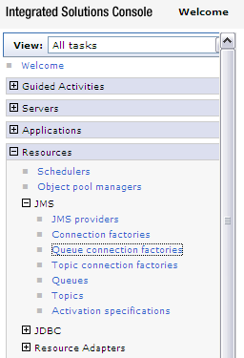
- Specify the scope. Ensure that the correct Node and Server is selected.
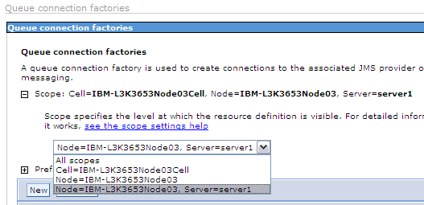
- Click on “New”.
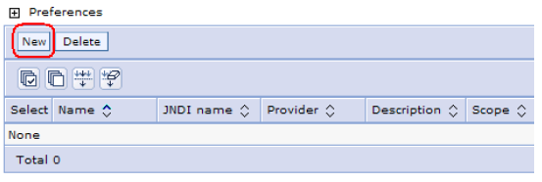
- For the “JMS resource provider” specify: WebSphere MQ messaging provider.
Click OK.
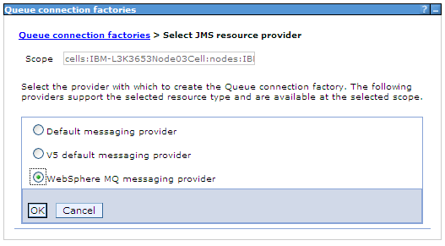
- In the General Properties, specify:
Name, JNDI Name, Queue manager, Host, Port, and Channel, refer to ESB Connectivity Parameters
Transport type: CLIENT
Click OK.
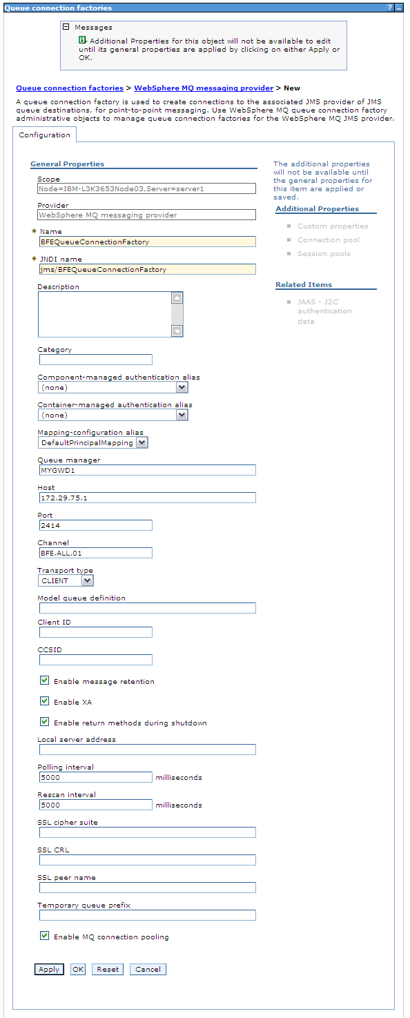
- You should see the new queue connection factory. Click on “Save”.
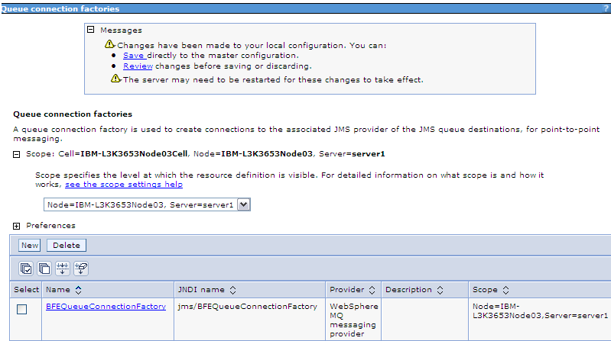
- Create the new Queue Destination by clicking on: Resources > JMS > Queues
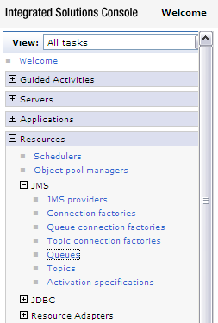
- Specify the scope. Ensure that the correct Node and Server is selected.
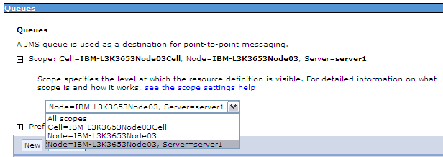
- Click on “New”.
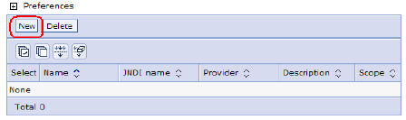
- For the “JMS resource provider” specify: WebSphere MQ messaging provider.
Click OK.
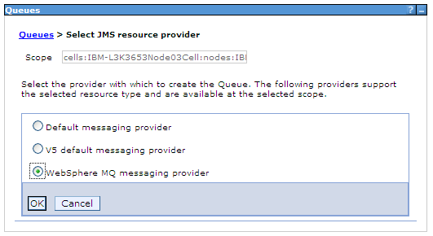
- In the General Properties, specify:
Name, JNDI Name, Base queue name, Queue manager host, port, and channel, refer to ESB Connectivity Parameters
Click OK.
Note:
- The Base queue manager name is not set because this is a clustered queue.
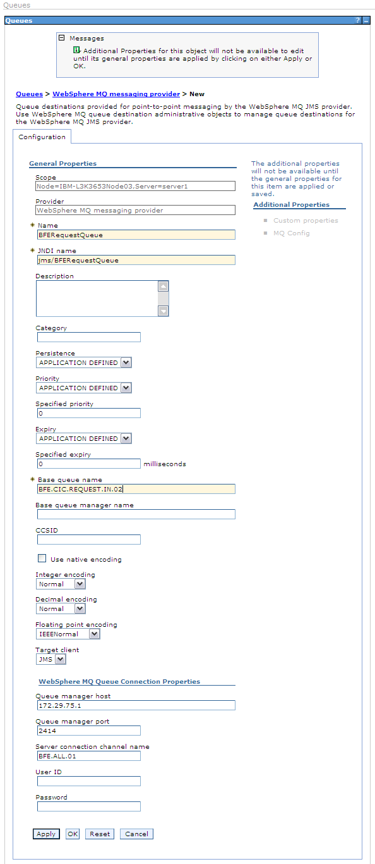

- You will see a new JMS Queue. Click on Save.
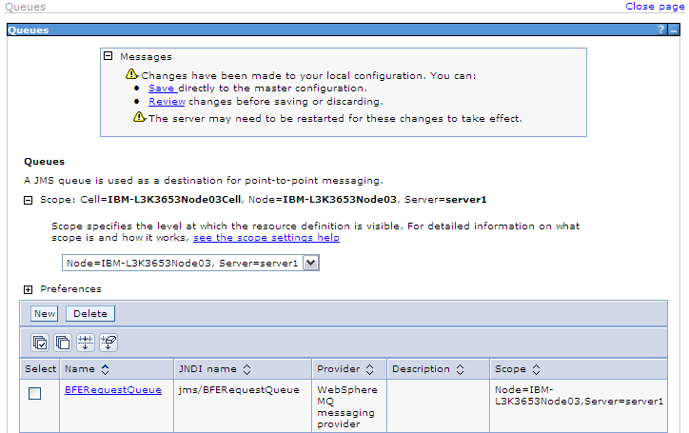
- For creating the Response Queue, repeat steps 8 to 12.
Note:
- Base queue manager name is set here.
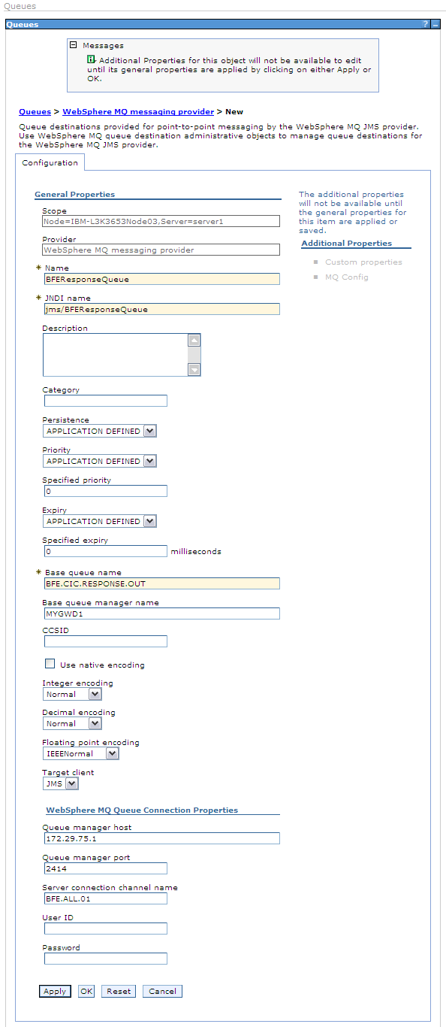

- You will see the new JMS Queue. Click on Save
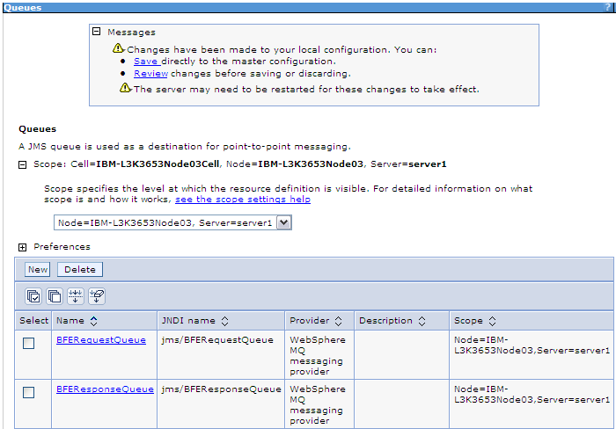
- Restart the server to reflect all the changes.

WAS 7
In this section, you will configure the WebSphere Application Server v7 to create the JMS resources.
- Go to the WebSphere Administrative Console and login.
- From the left panel, select: Resources > JMS > Queue connection factories
- Specify the scope. Ensure that the correct Node and Server is selected.
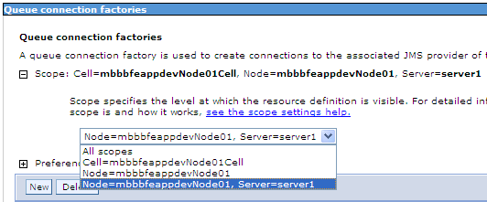
- Click on “New”.
- For the “JMS resource provider” specify: WebSphere MQ messaging provider.
Click OK.
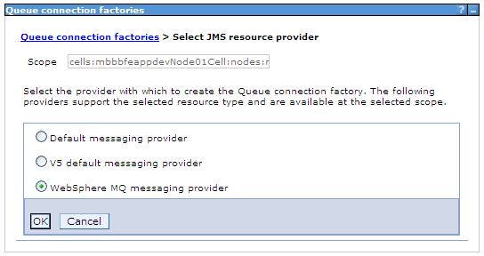
- In the “Step 1: Configure basic attributes” specify:
Name and JNDI Name (refer to ESB Connectivity Parameters)
Click Next.
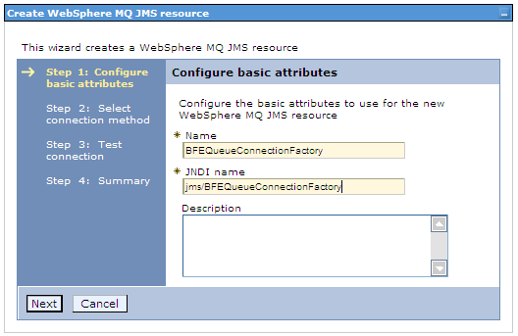
- In the “Step 2: Select connection method” accept the default:
Enter all the required information into this wizard
Click Next.
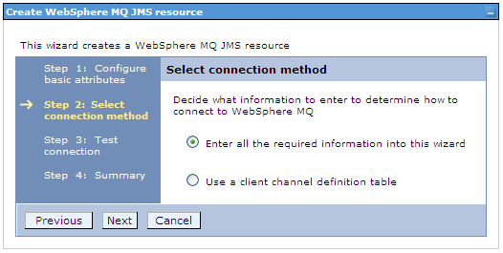
- In “Step 2.1: Supply queue connection details” specify:
Queue manager (refer to ESB Connectivity Parameters)
Click Next.
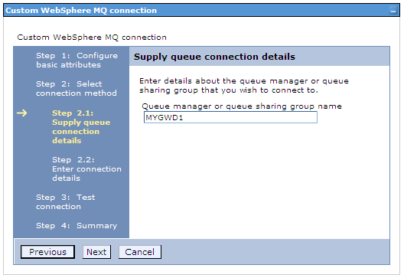
- In “Step 2.2: Enter connection details” specify:
Transport => Client
Hostname, Port, Server connection channel (refer to ESB Connectivity Parameters)
Click Next.
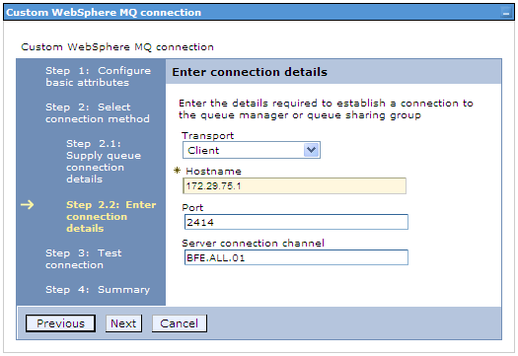
- In “Step 3: Test Connection” click on the button “Test connection”.
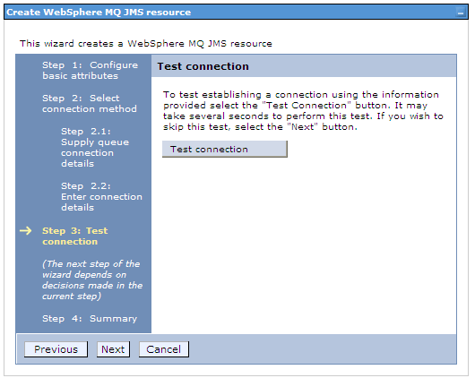
- In “Step 3.1: Test connection result”, you should see a successful report:
“A connection was successfully made to WebSphere MQ”
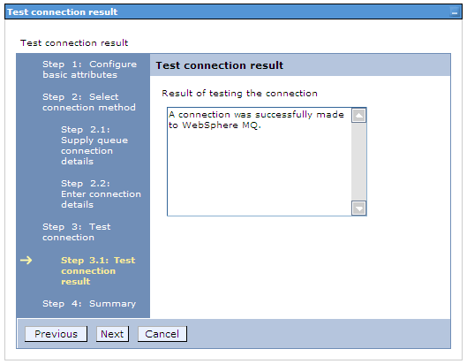
- In “Step 4: Summary” you should see the data to be used to create the object.
Click on Finish.
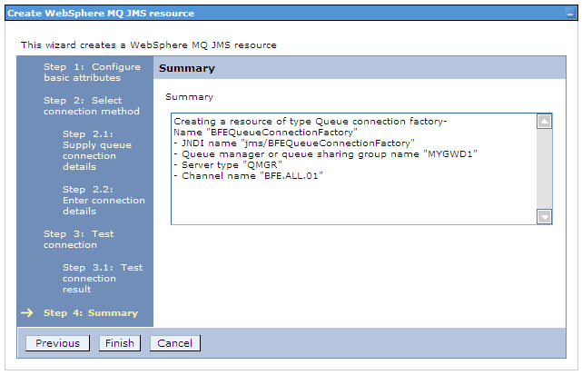
- You should see the new queue connection factory. Click on “Save”.
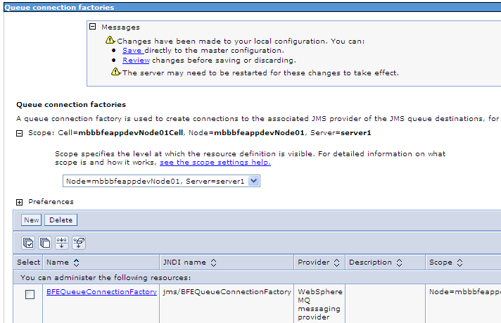
- Create the new Queue Destination by clicking on: Resources > JMS > Queues
- Specify the scope. Ensure that the correct Node and Server is selected.
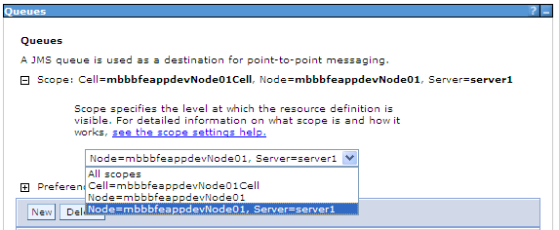
- Click on “New”.
- For the “JMS resource provider” specify: WebSphere MQ messaging provider.
Click OK.
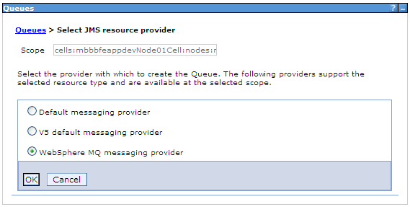
- In the General Properties, specify:
Name, JNDI Name, Base queue name, (refer to ESB Connectivity Parameters)
Click OK.
Note:
- The Base queue manager name is not set because this is a clustered queue.
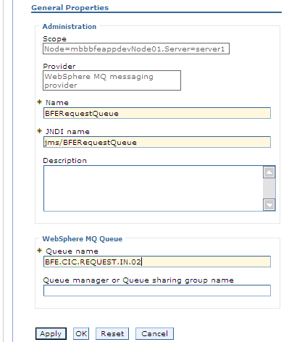

- You will see a new JMS Queue. Click on Save.
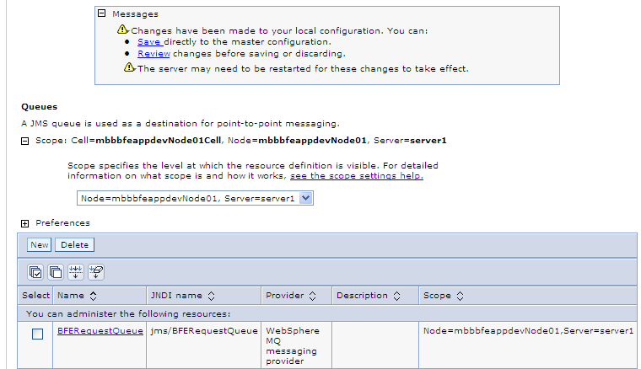
- For creating the Response Queue, repeat steps 14 to 17.
Then in the General Properties, specify:
Name, JNDI Name, Base queue name, and Base queue manager name, refer to ESB Connectivity Parameters
Click OK.
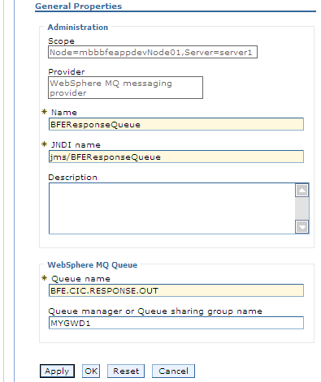

- You will see the new JMS Queue. Click on Save
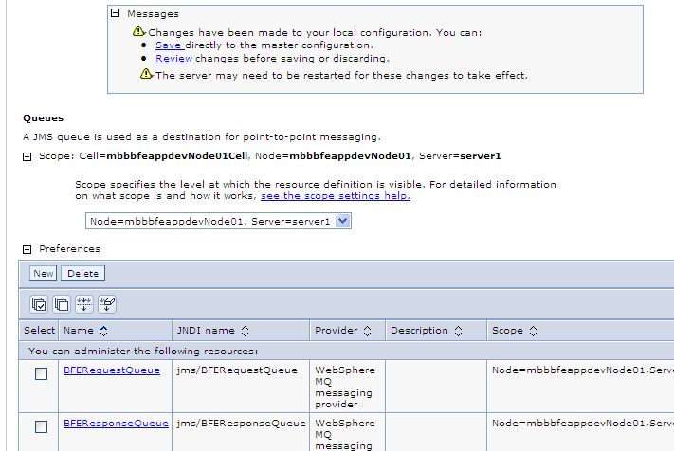
- Restart the server to reflect all the changes.

